CodeAlpha Internship – Task 3
Secure Coding Review Report

Intern Name: Zain Ul Abideen
Internship: CodeAlpha
Domain: Cybersecurity
Task: Secure Coding Review

1. Selected Programming Language and Application
- Programming Language: Python
- Application Type: Simple Web Application (User Login System)
- Framework (assumed): Flask (for analysis purposes)
The application handles user authentication using username and password input and interacts with a backend database.

2. Scope of Code Review
The code review focuses on identifying common security vulnerabilities related to:
- Input validation
- Authentication and authorization
- Data handling
- Error handling
- Secure coding practices
Both manual inspection and static analysis concepts were applied.

3. Sample Code Reviewed (Vulnerable Example)

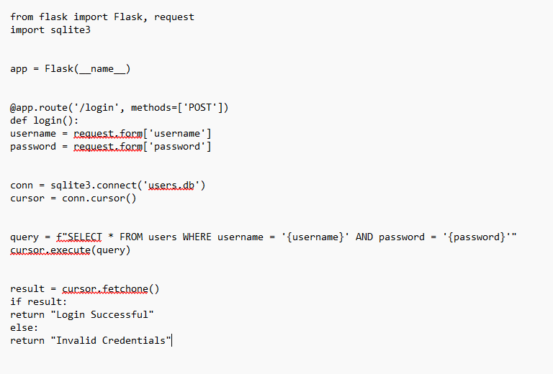
4. Identified Security Vulnerabilities

4.1 SQL Injection
- Issue: User input is directly concatenated into SQL queries.
- Impact: Attackers can bypass authentication or extract sensitive data.

4.2 Plaintext Password Storage
- Issue: Passwords are compared and stored in plaintext.
- Impact: If the database is compromised, all user passwords are exposed.
4.3 Lack of Input Validation
- Issue: No validation or sanitization of user input.
- Impact: Enables injection attacks and unexpected application behavior.
4.4 Missing Error Handling
- Issue: Database errors are not handled properly.
- Impact: Application may crash or leak sensitive information.
4.5 No Authentication Rate Limiting
- Issue: Unlimited login attempts allowed.
- Impact: Susceptible to brute-force attacks.

5. Tools and Techniques Used
5.1 Manual Code Review
- Line-by-line inspection
- Identification of insecure patterns
- OWASP Top 10 mapping
5.2 Static Analysis Tools (Recommended)
- Bandit – Python security linter
- SonarQube – Code quality and security analysis
- Semgrep – Pattern-based static analysis

6. Recommendations and Secure Coding Best Practices
6.1 Use Parameterized Queries
Prevent SQL Injection by using prepared statements.
6.2 Hash Passwords Securely
Use strong hashing algorithms such as bcrypt or Argon2.
6.3 Validate and Sanitize Inputs
Apply strict validation rules for all user inputs.
6.4 Implement Proper Error Handling
Avoid exposing stack traces or database errors to users.
6.5 Apply Rate Limiting and Account Lockout
Protect authentication endpoints from brute-force attacks.

7. Secure Code (Remediated Example)
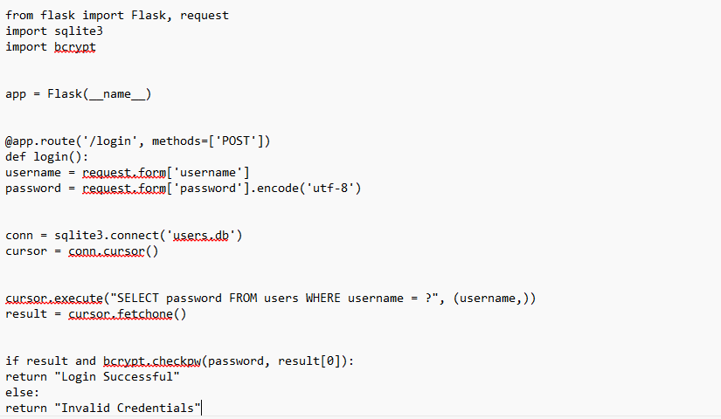

8. Remediation Summary

Vulnerability | Risk Level |  | Fix Applied
SQL Injection | High |  | Parameterized Queries
Plaintext Passwords | High |  | Password Hashing
Input Validation | Medium |  | Validation Rules
Error Handling | Medium |  | Secure Error Messages
Brute Force Risk | Medium |  | Rate Limiting

